**OWLEXCHANGE**

**USER MANUAL**

Description:

The OwlExchange project is a community-focused modular eCommerce platform sponsored by Assurant Global Technology, with the guidance from our mentors Robert Fortunato and Norbert Monfort, designed as a multi-semester capstone initiative. OwlExchange aims to provide a centralized web application that allows college users to donate, exchange and resell household and personal items in a structured, user-friendly and efficient way.

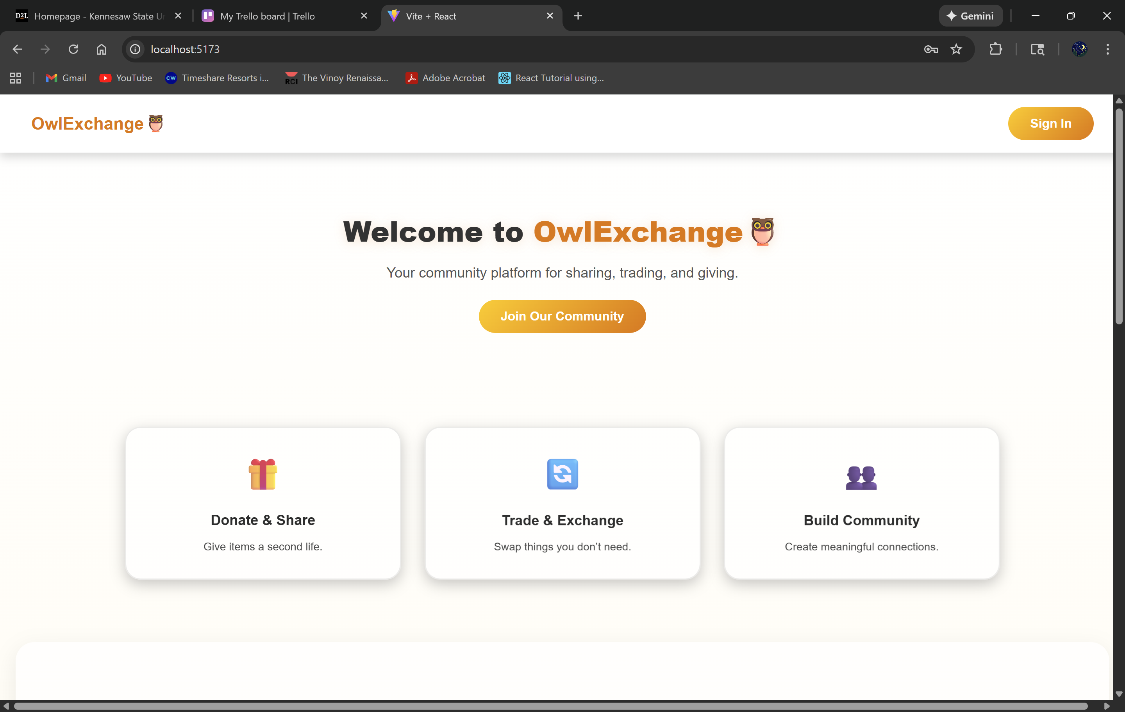

Home Screen:

* Click on the Sign in/ Join Our Community buttons will take you to our login screen
* Displays the different services we provide as a website

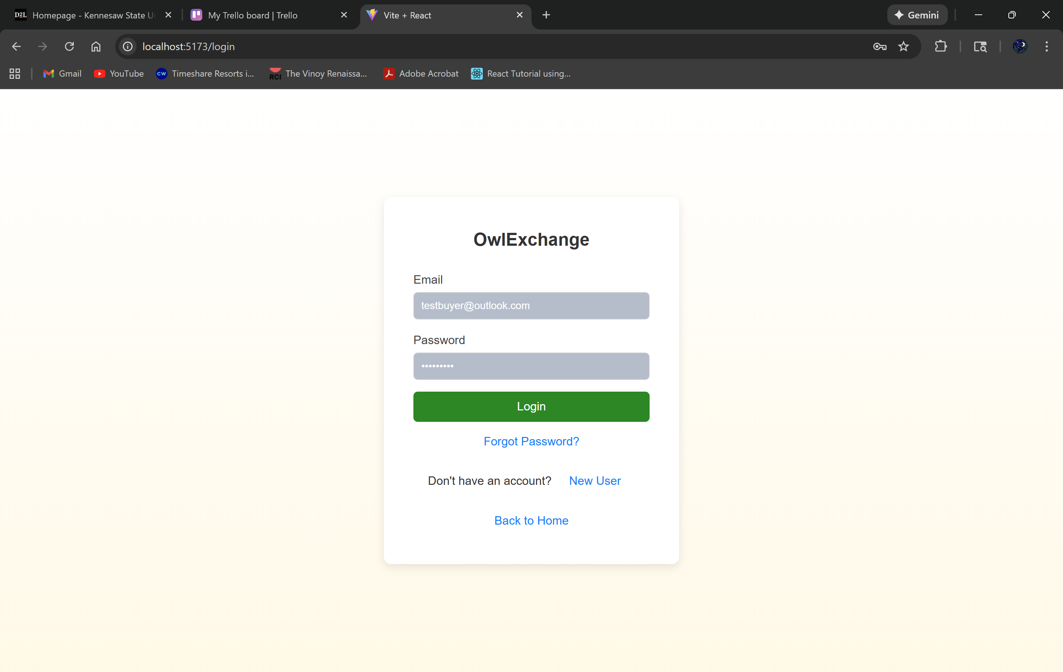

Login Screen:

* You’ll enter your email as your username on the first line
* You’ll enter your password on the second line
* Then you’ll click “Login” to go to the user dashboard

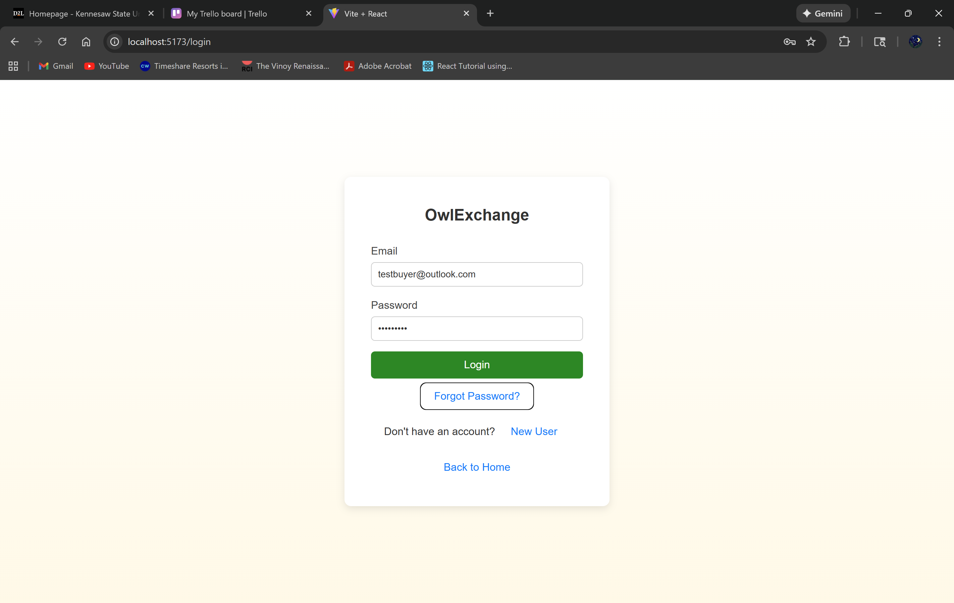

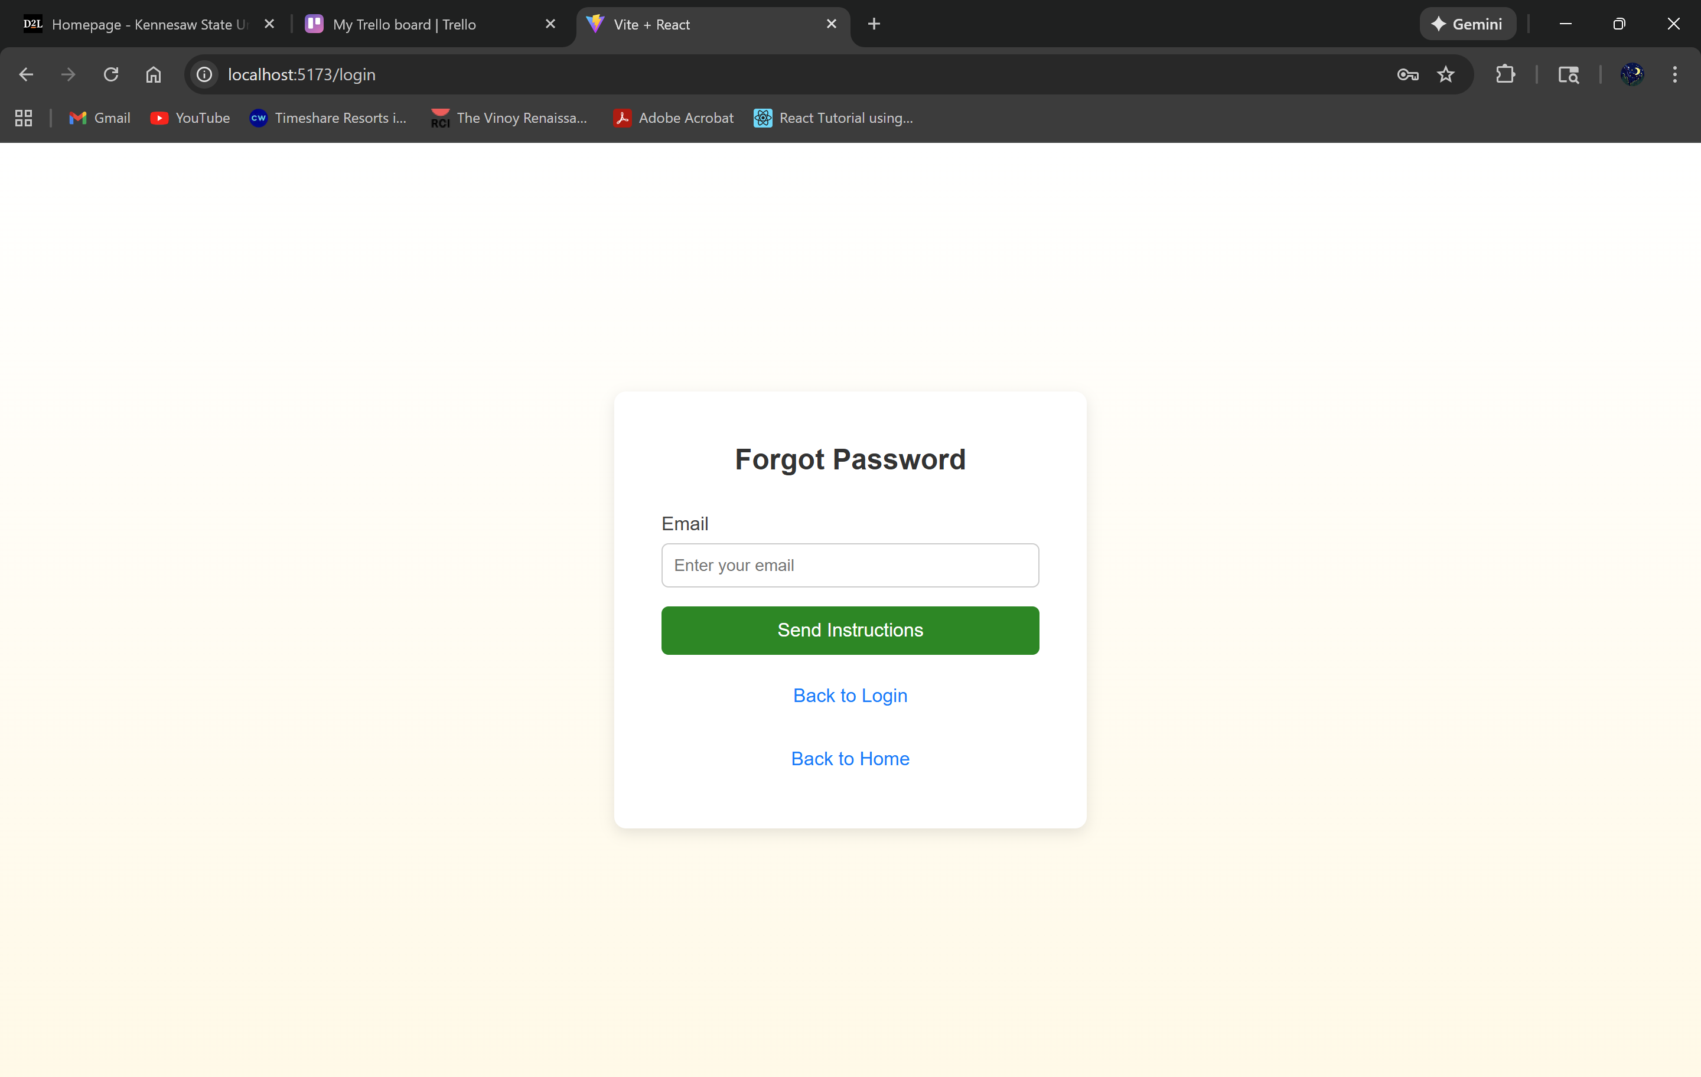

Forgot Password:

* Allow users to recover their account by entering their email address
* Then click the “Send Instructions” button to get the instructions to recover their account.



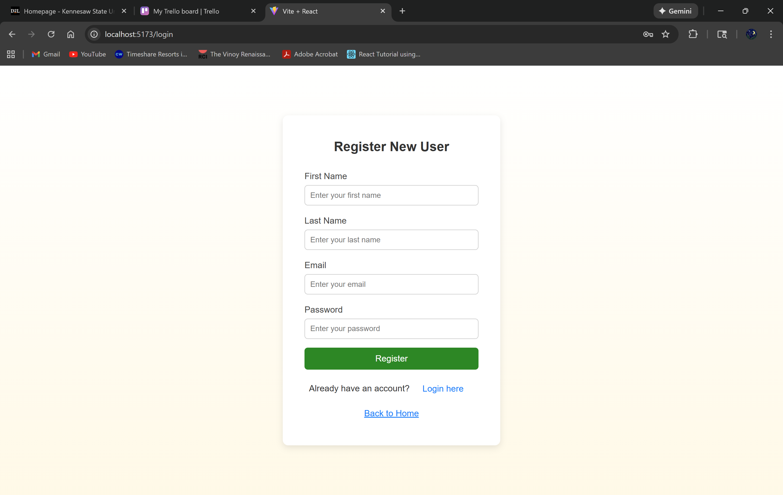

New User:

* Fill out the following fields and then click the “Register” button to create your profile and login information
* Then click the “Login here" button to enter your login information or click the “Back to Home" button to simply go back to the homepage

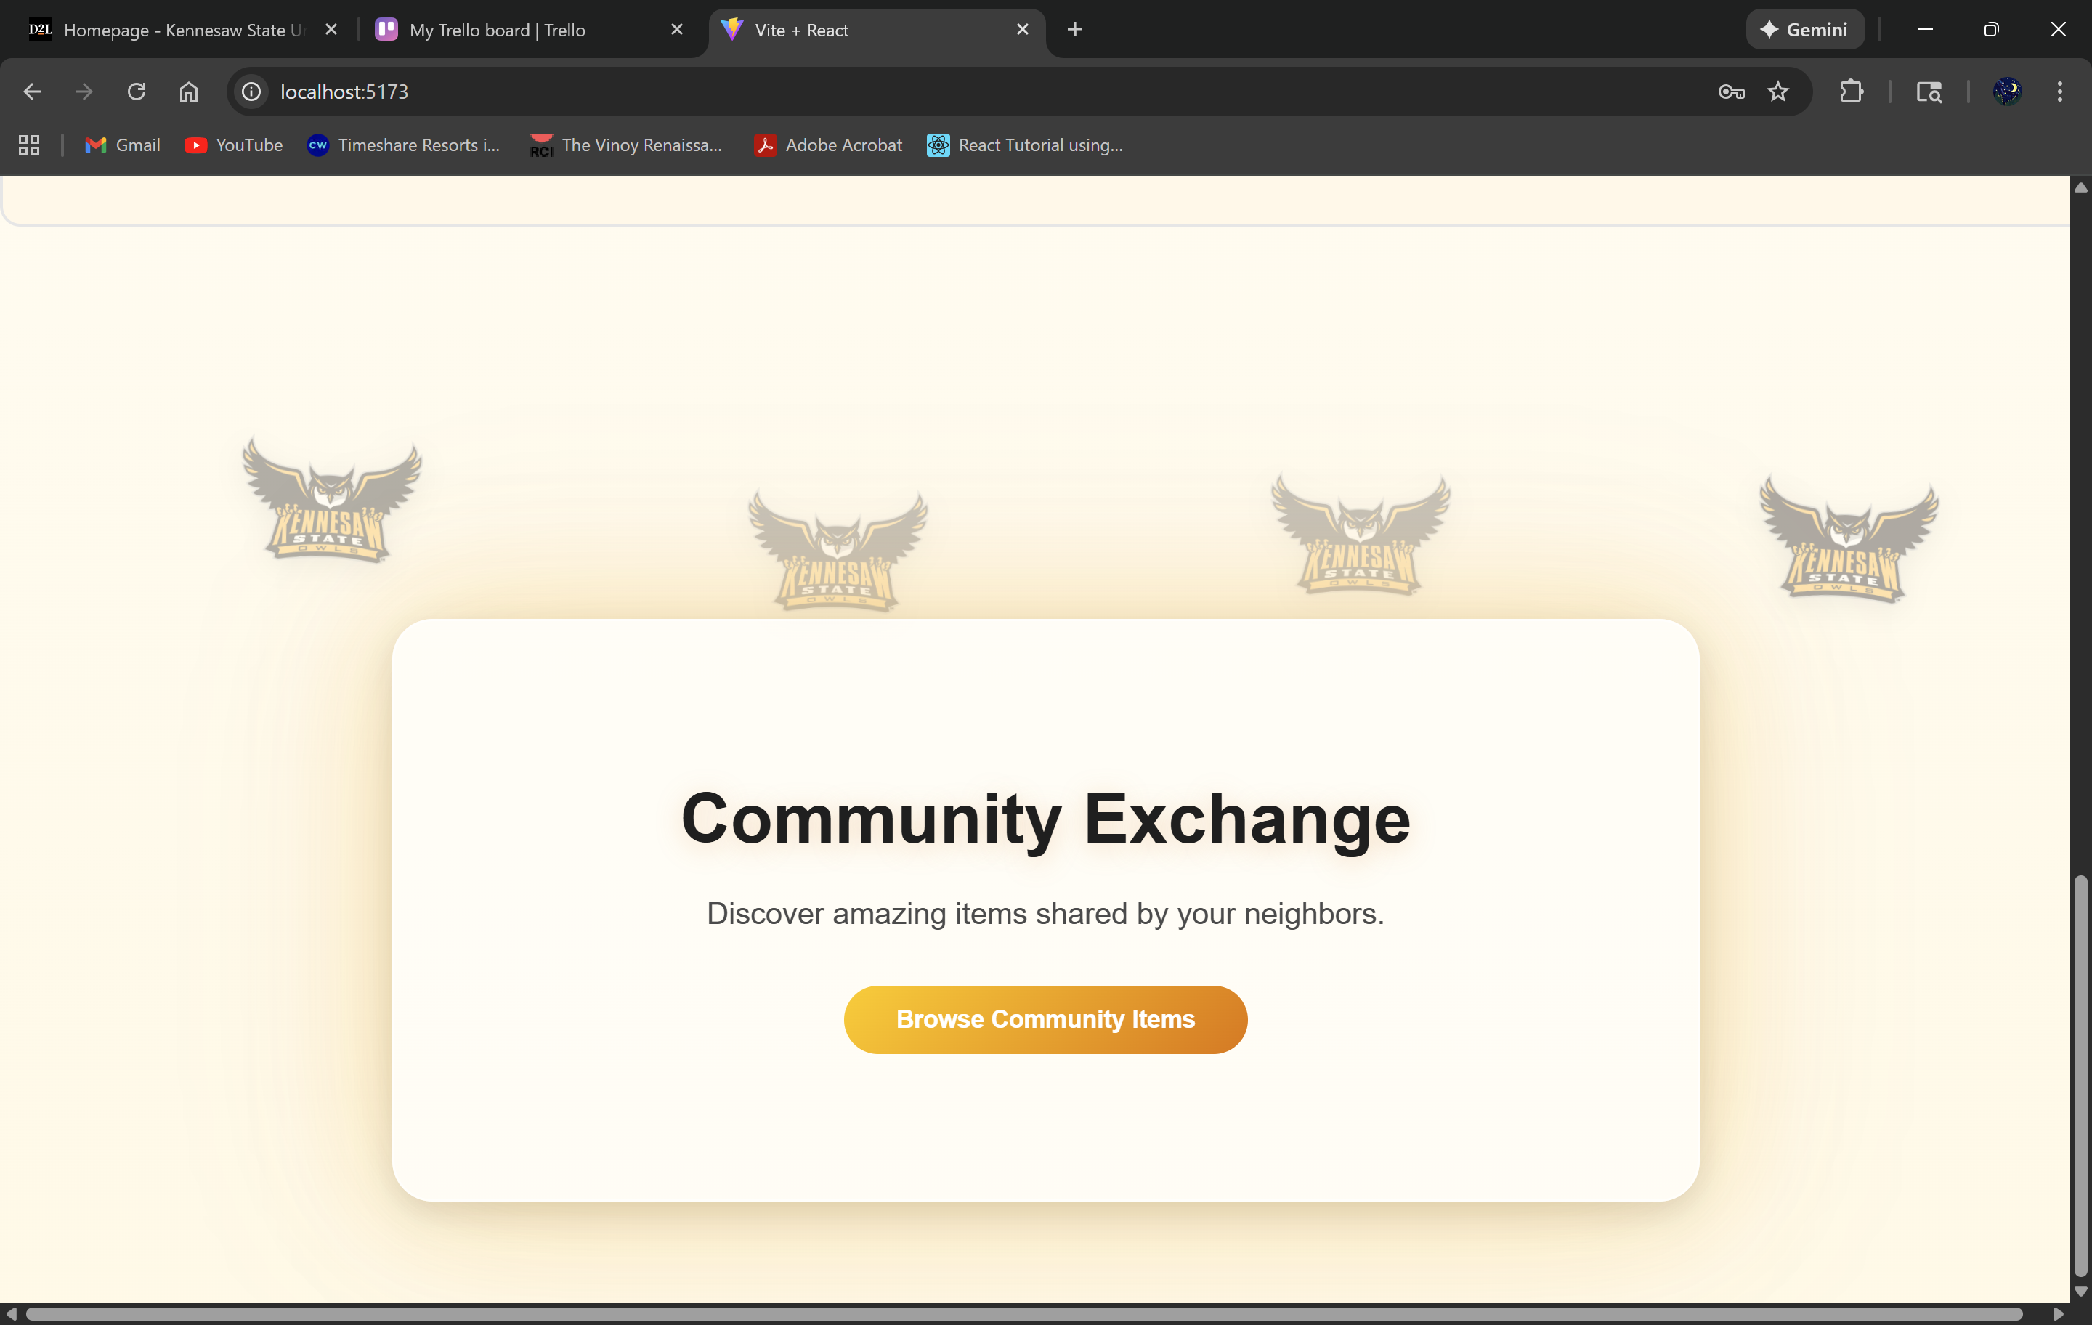



Community Exchange:

* Scroll down to the bottom of the screen and you’ll see the Community Exchange section, click the “Browse Community Items” button to view current items that are available to buy, receive donation, or receive trade

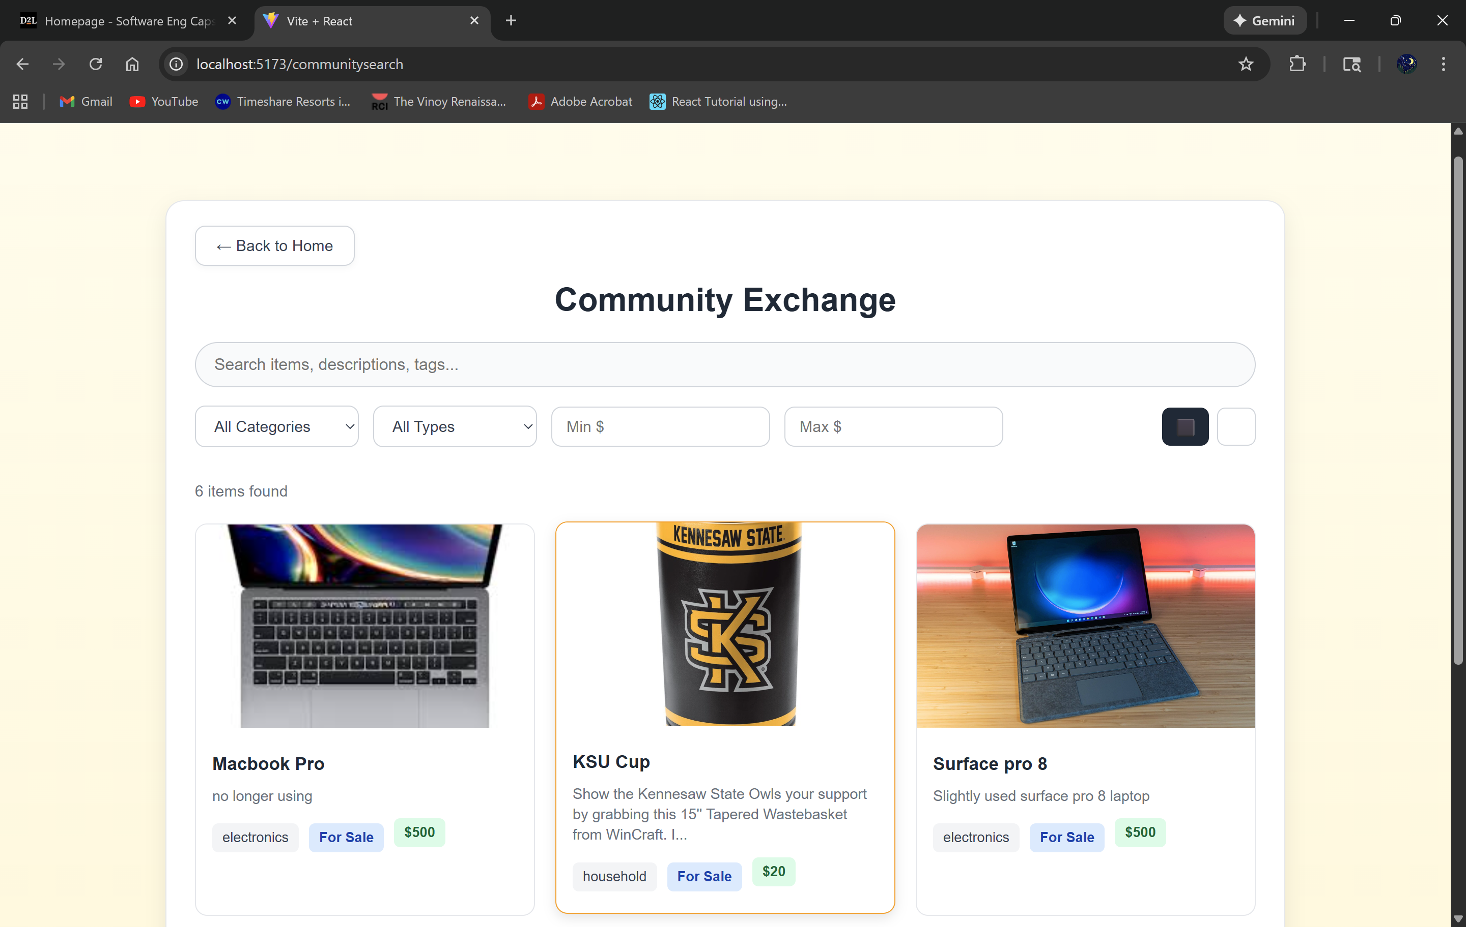



Community Exchange Search Menu:

* Users can search for a particular item they want by using the search bar
* Users can view the items on the page underneath the search bar and filters

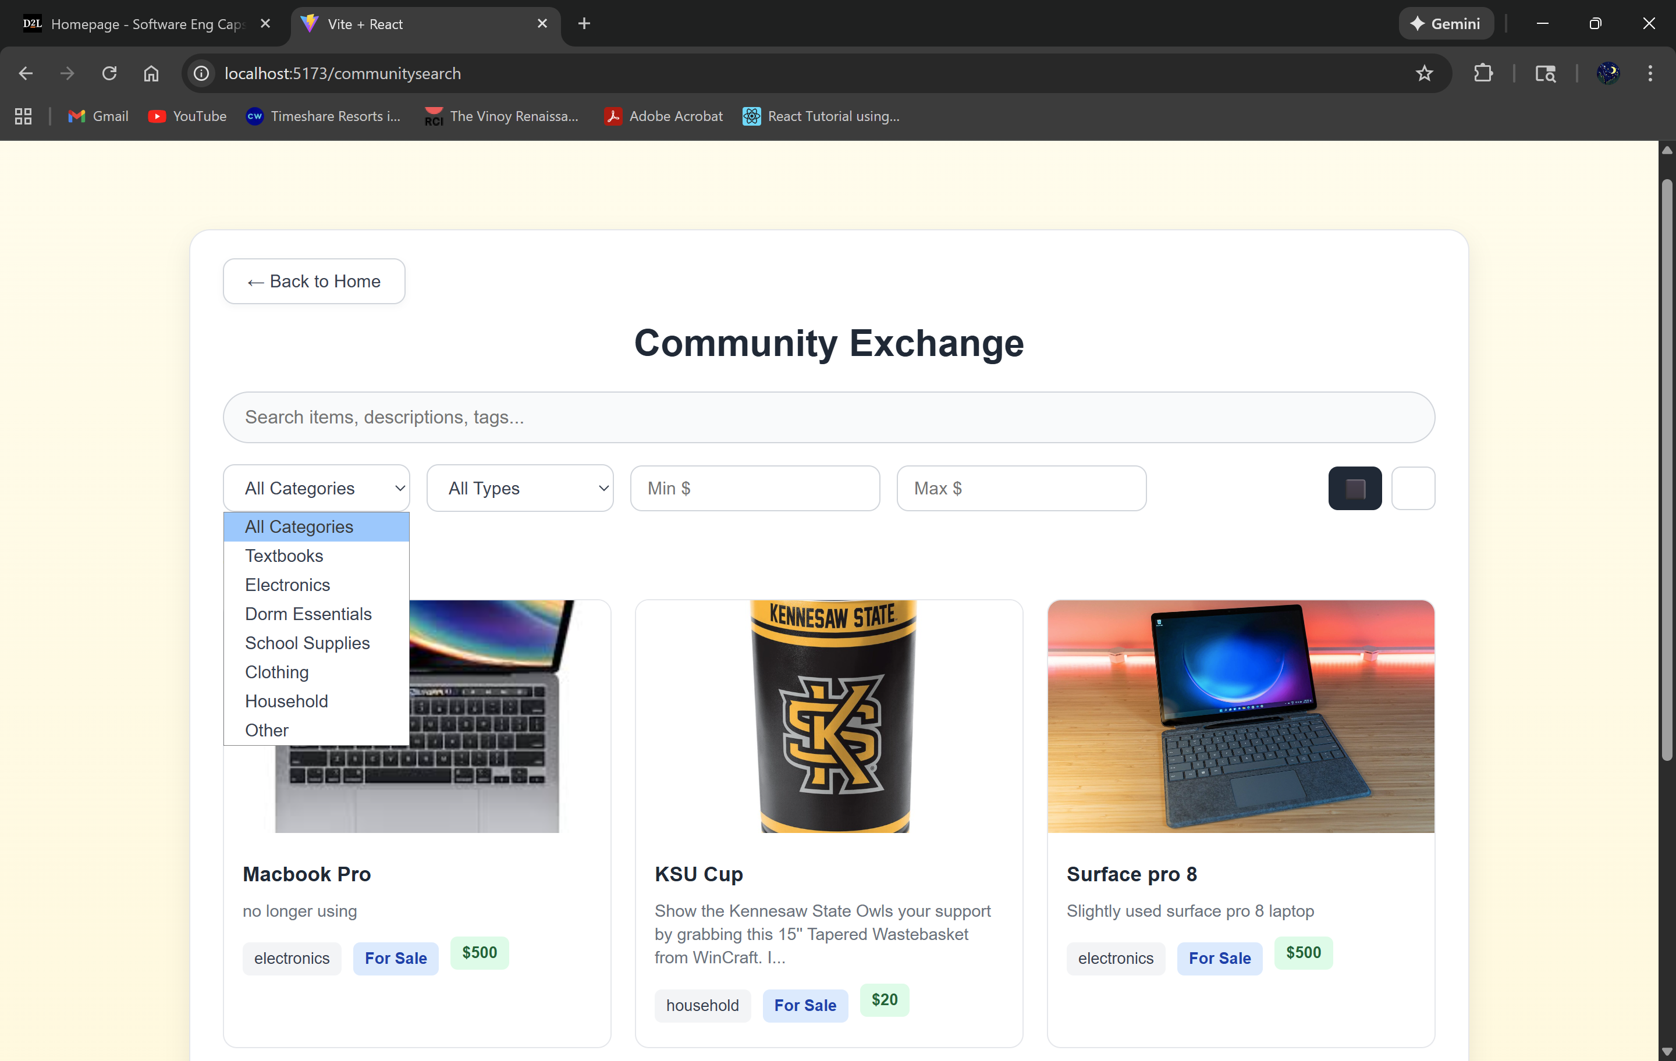

Category Filter:

* Filter by the types of items like electronics by clicking the “All Categories” button

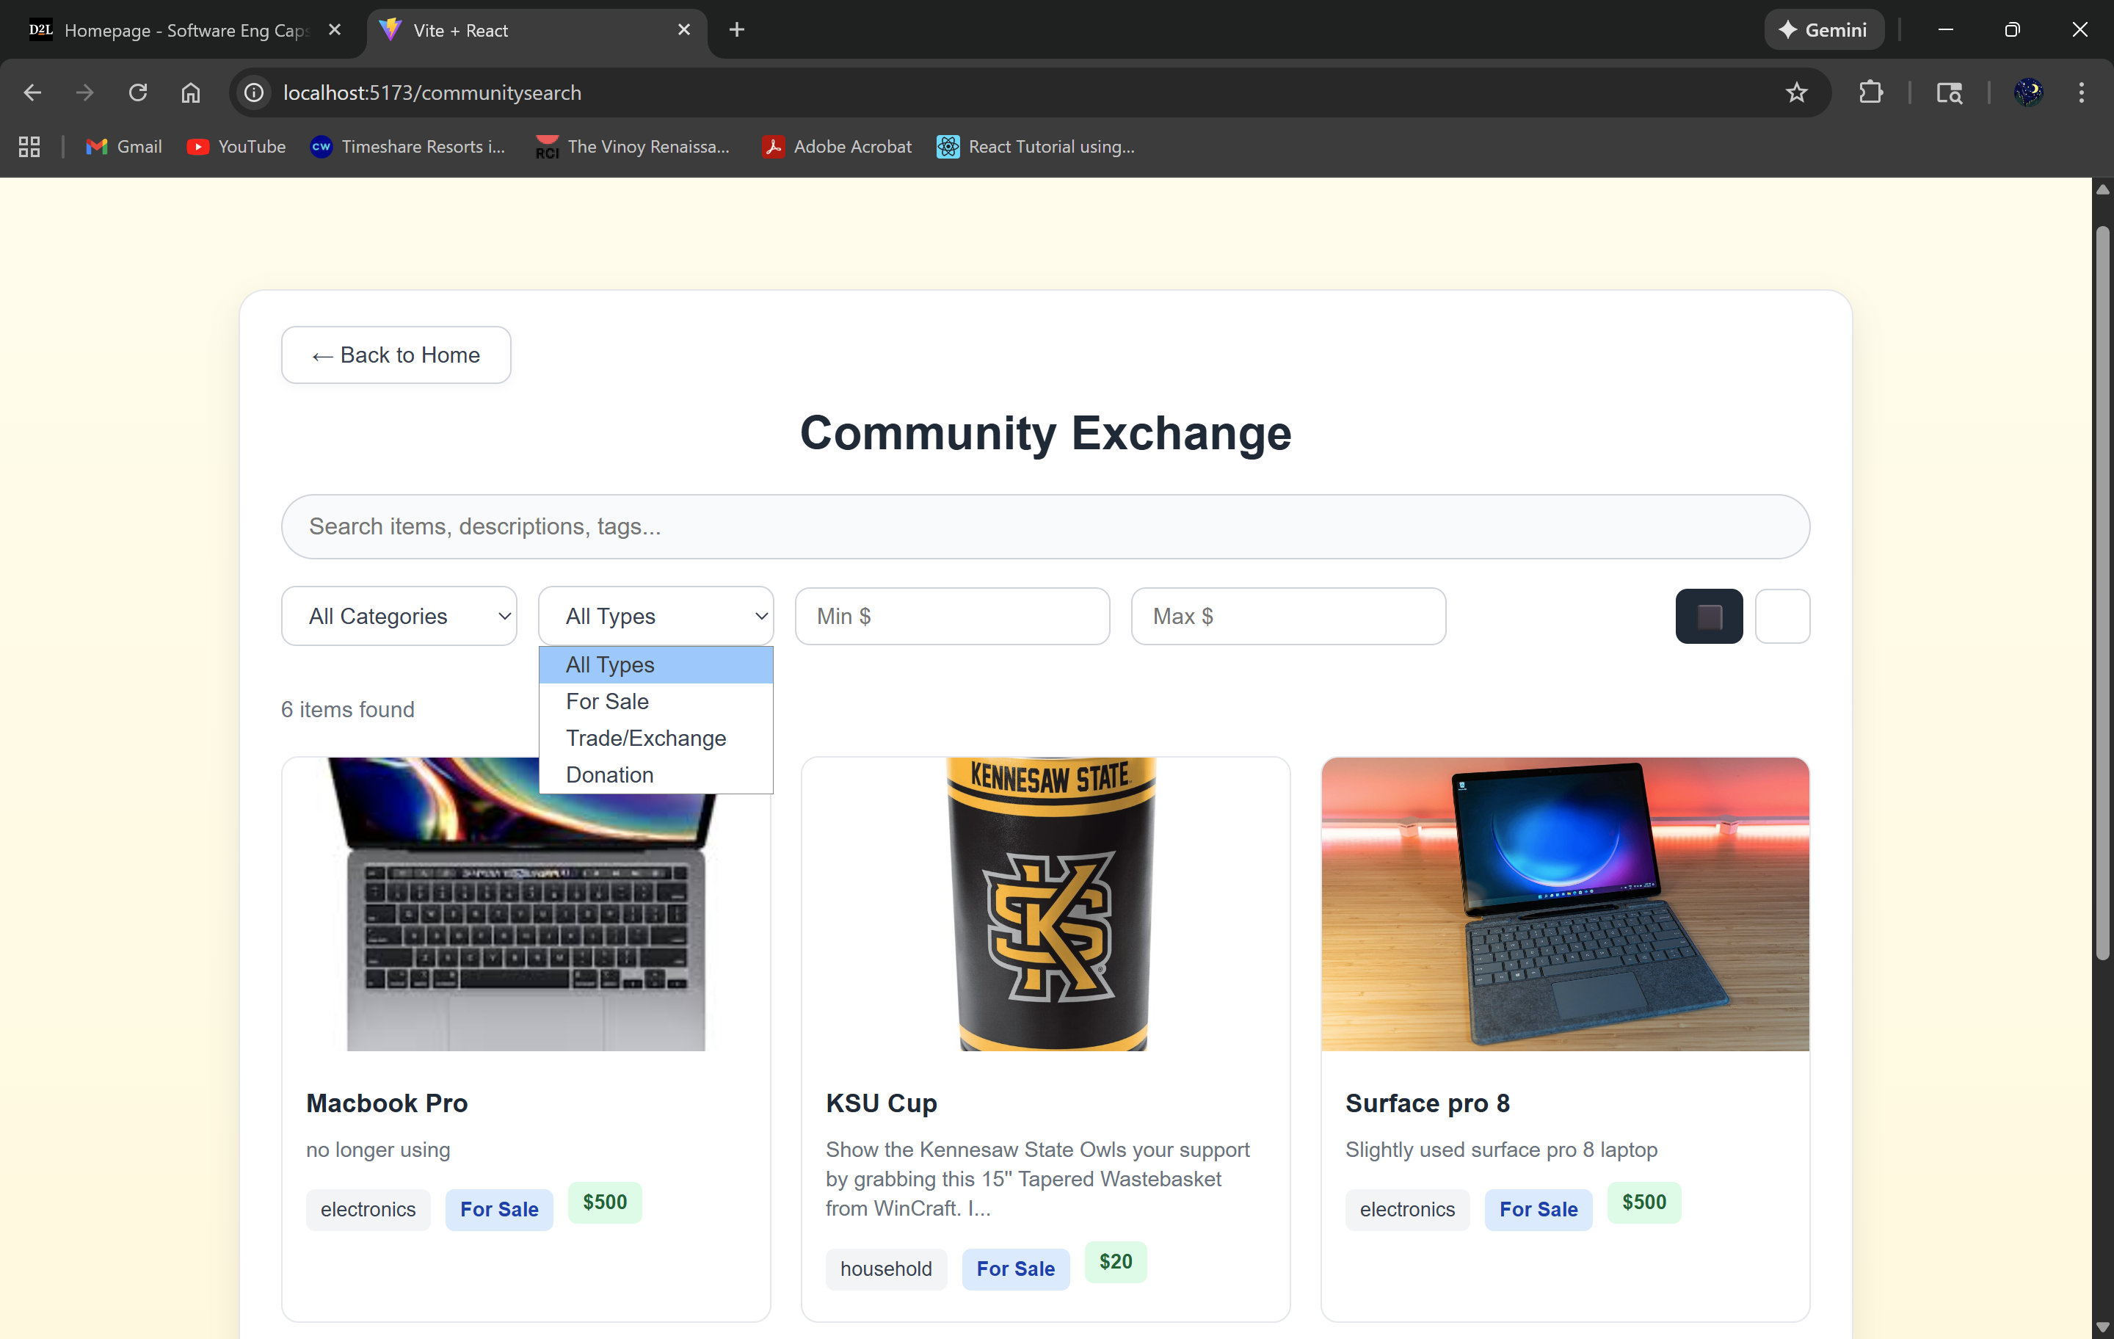

All Types Filter:

* Filter between which items are for sale, trade, donation by clicking the “All Types” button

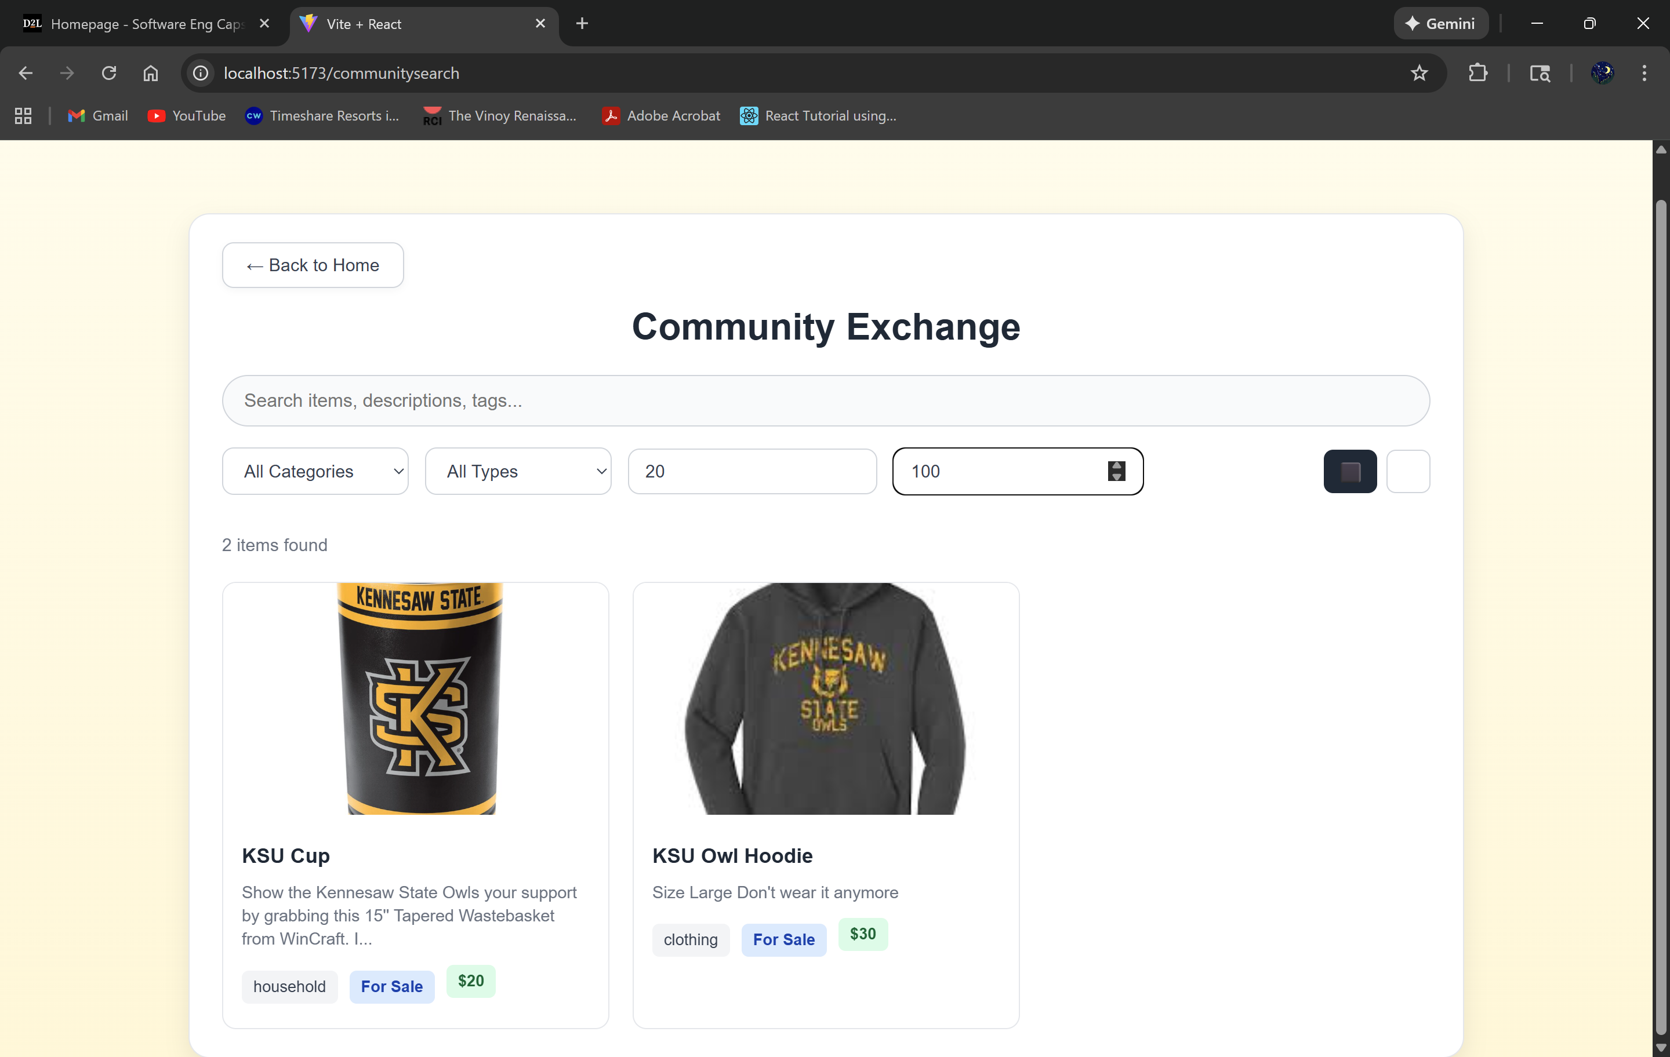

Filter by minimum/maximum amounts:

* Users can filter through a price range if they have a budget when viewing the items

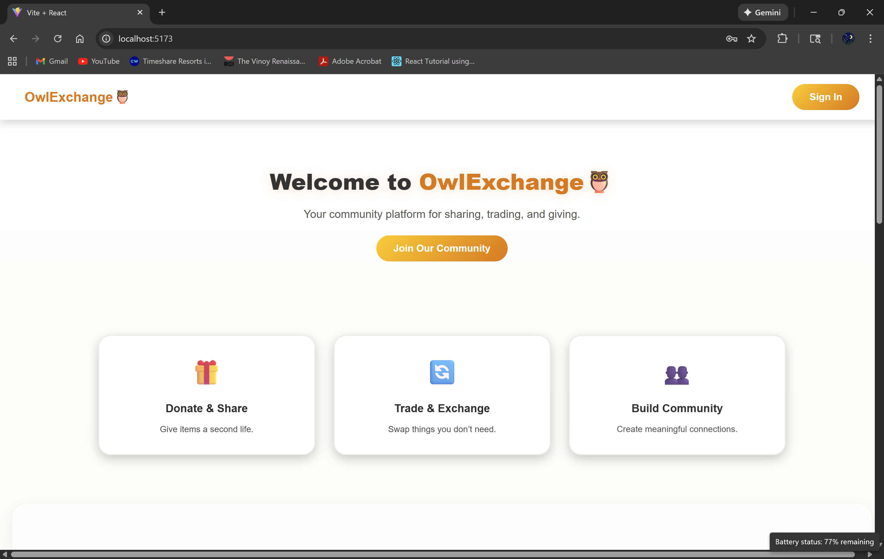



* Click the “sign in” button to go to the login screen



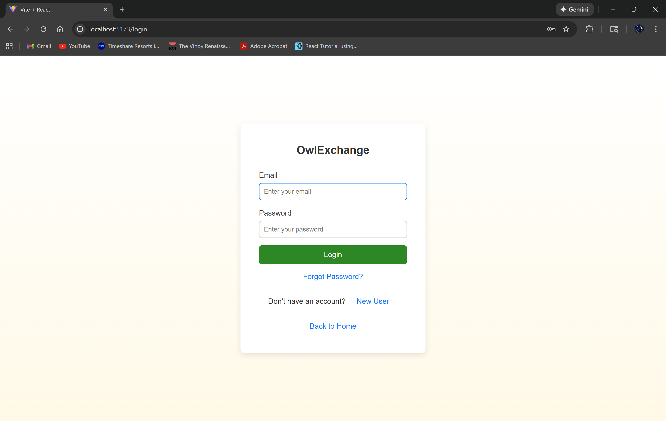

* Login with your information

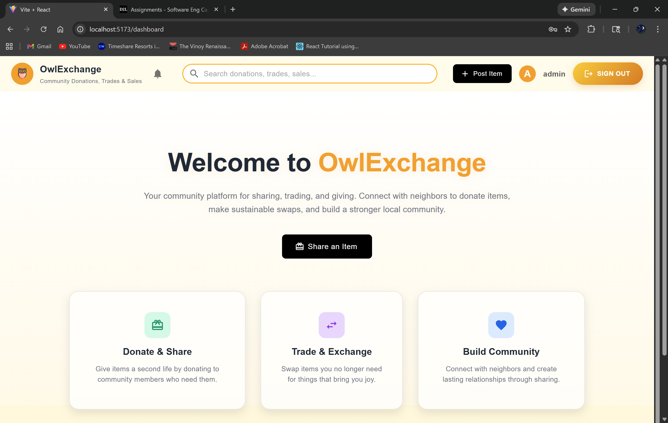



* This is the user dashboard
* The “post item” button and “Share and Item” button is where users can post items
* The search bar so the user can search for items
* Notification bell on the left of the search bar

Top of the Post Item section

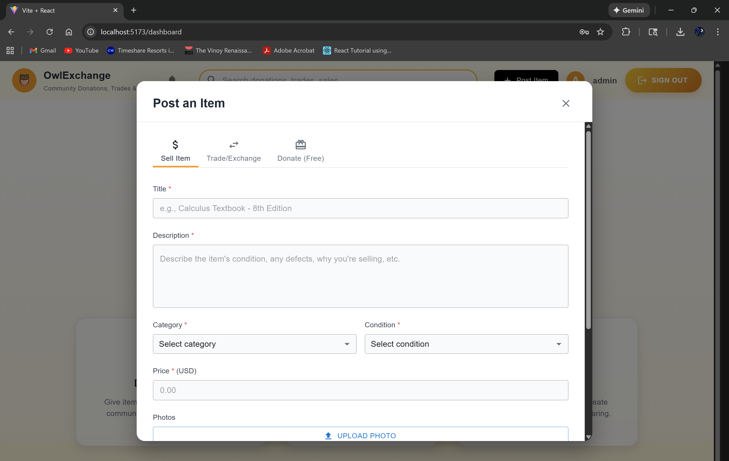

Bottom of the Post Item section

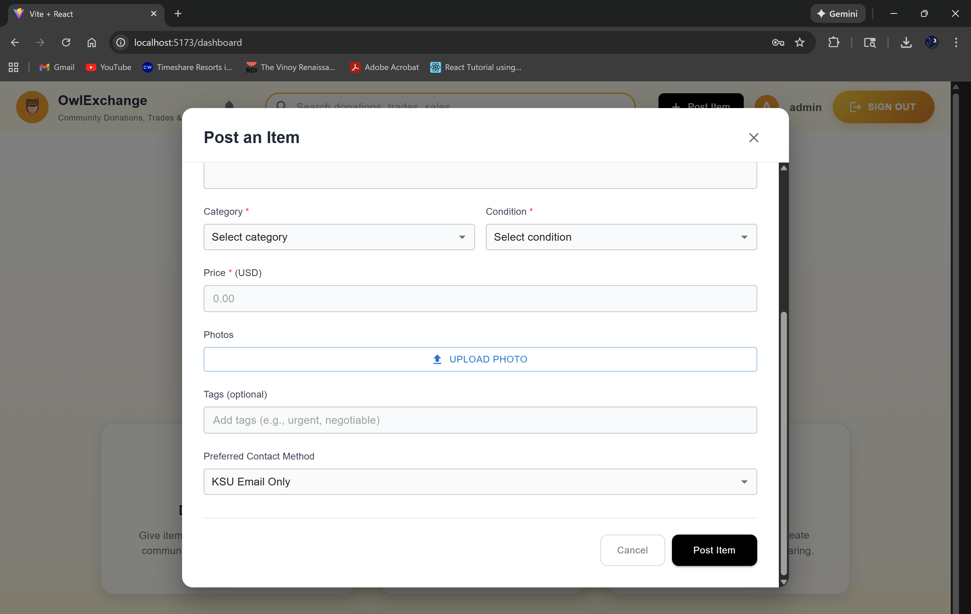

Sell section in the Post Item/ Share an Item

* Fill the information in the text fields
* Click “Post Item” to add it to the marketplace towards the bottom of the section

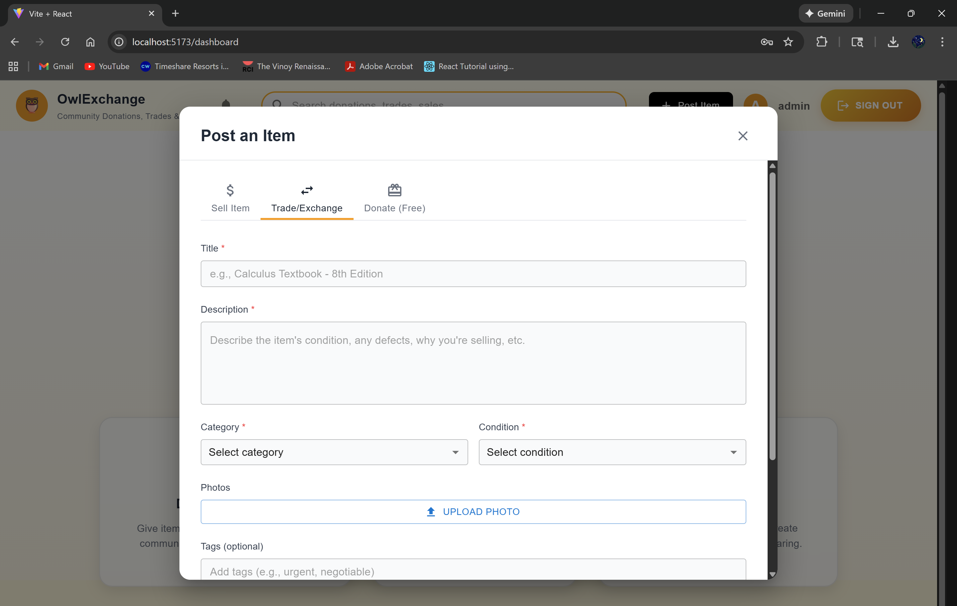

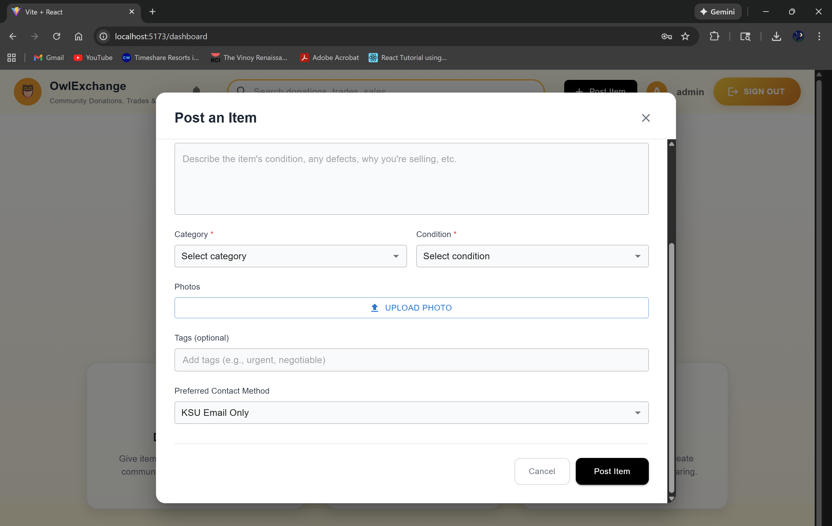

Trade section in the Post Item/ Share an Item

* Fill the information in the text fields
* Click “Post Item” to add it to the marketplace towards the bottom of the section

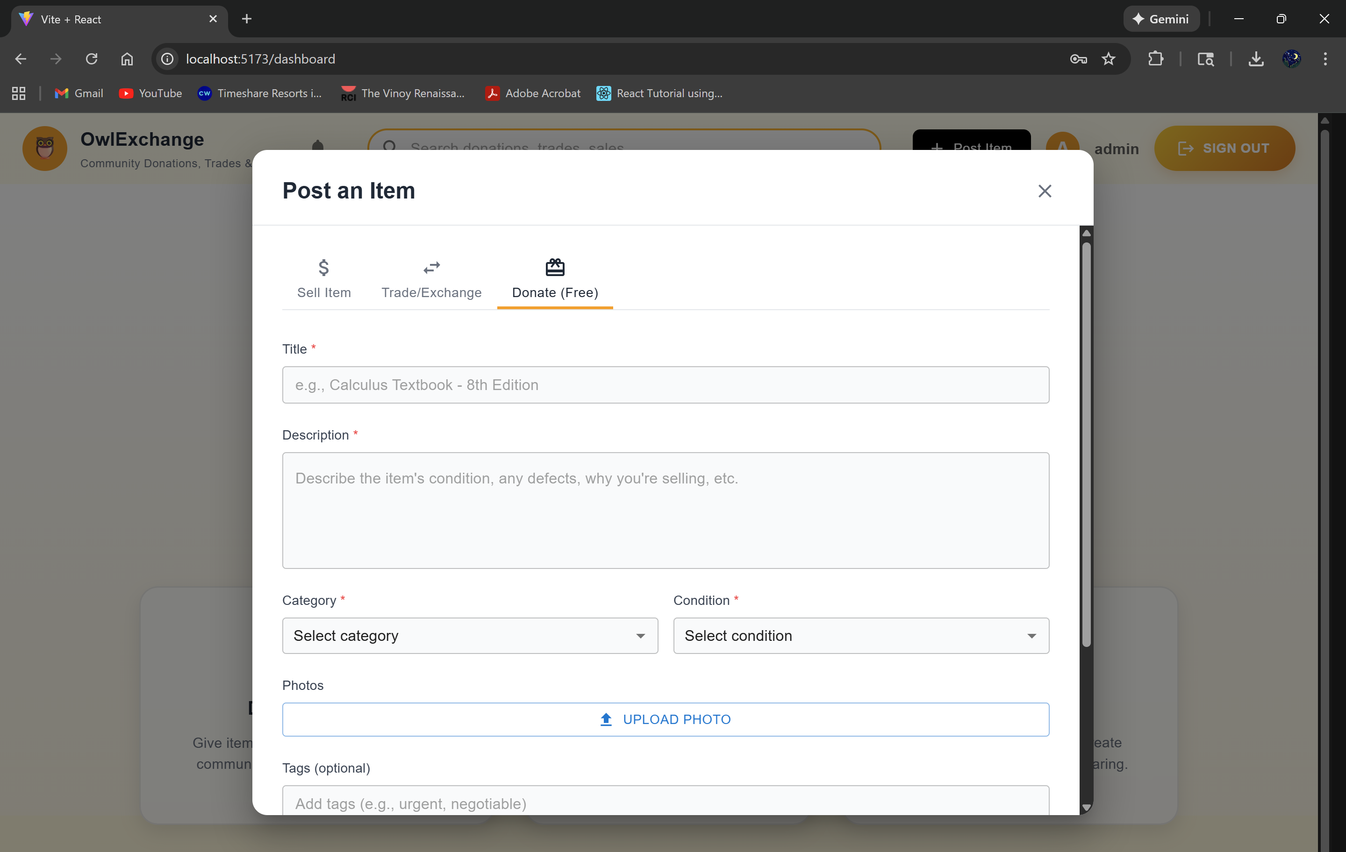



Donation section in the Post Item/ Share an Item

* Fill the information in the text fields
* Click “Post Item” to add it to the marketplace towards the bottom of the section

